**PRIME FITNESS**

**WORK HARDER, GET STRONGER**

**EASY WITH OUR GYM**

|  |  |  |
| --- | --- | --- |
| FACULTY NAME | SIR KASOUR,miss esha | |
| BATCH | 2109D | |
| GROUP | PRIME FITNESS | |
| SERIAL NO: | ENROLLMENT NO | STUDENT NAME |
|  | 1335299 | M. SAIM JAWED |
|  | 1335013 | RIDA EMAN |
|  | 1335280 | INSIYA YOUSUF |
|  | 133 | EBAD-UL-HASSAN |

ACKNOWLEDGEMENT

*We Would like to start with the name of Allah. The most beneficent and most merciful. All the praises and thank to Allah Who has given us strength and ability in proceeding to this project.*

*We would like to express our special thanks of gratitude to my teachers “Sir Kousar and Miss Esha Who helped a lot in finalizing our project within the limited time frame, valuable counseling and assistance for the accomplishment of this project.*

*We would also like to thanks the e-project team at Aptech Head office, who gave as the opportunity to do this interesting and wonderful project about PRIME FITNESS*

*We also thank the e-project team for giving this task to us.*

*Following*

*Are the benefits of this project:*

*Re-enforcement of skills happens in the experimental learning process.*

*A mentor, ensuring that we do not get drifted, constantly guide us.*

*It gives us a lot of confidence to face an interview awe have worked on a project. We can explain virtually everything on the subject we have learnt*

WEBSITE DETAIL

|  |  |
| --- | --- |
| Name | PRIME FITNESS |
| Theme color | RED,WHITE |
| Pages | 27 |
| Font Family | Time New Roman |
| Font color | RED,WHITE |
| Languages | Html, CSS, JavaScript, Bootstrap, jQuery. |
| Follow us | Facebook,instrgam,Youtube,Gmail |
| Gmail Name | Primefitness@gmail.com |

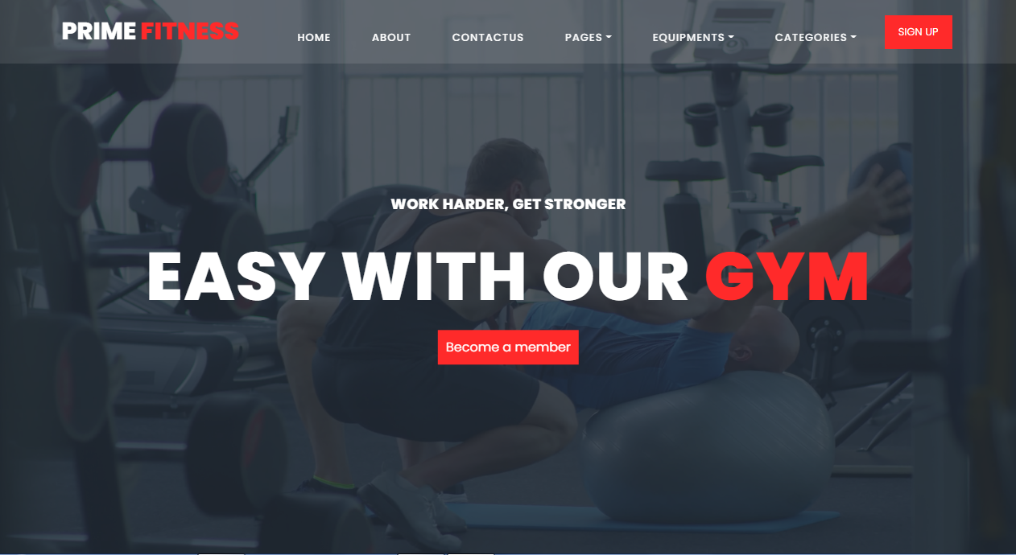

HEADER

Footer

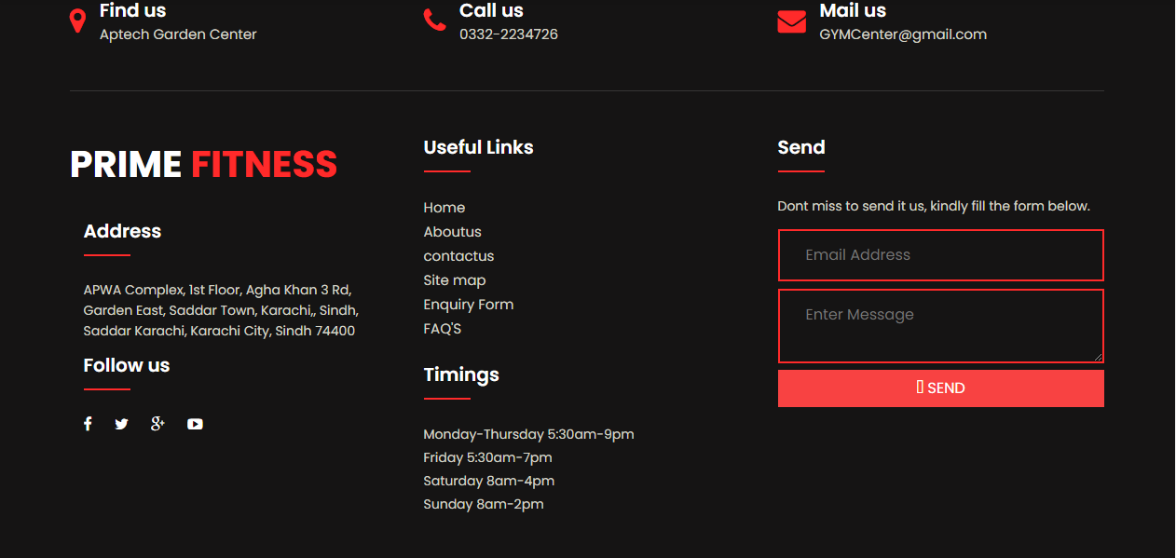

SITE MAP

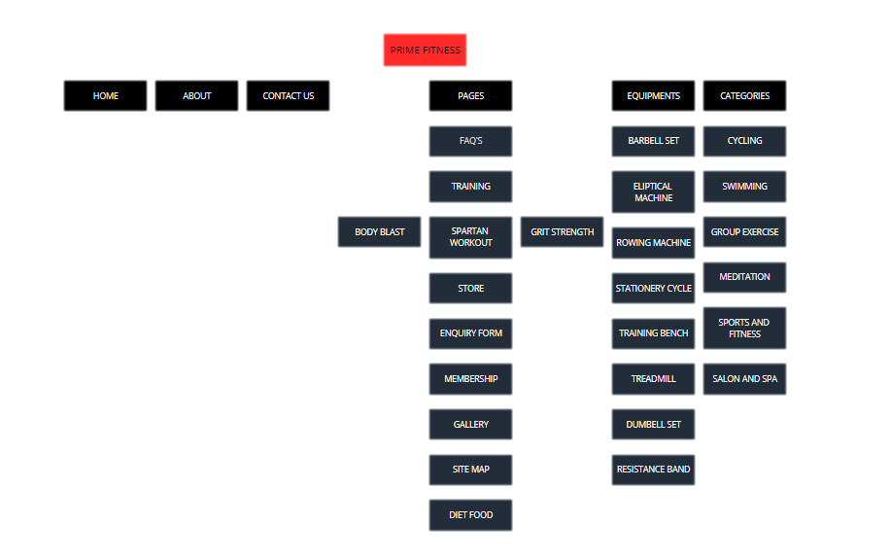

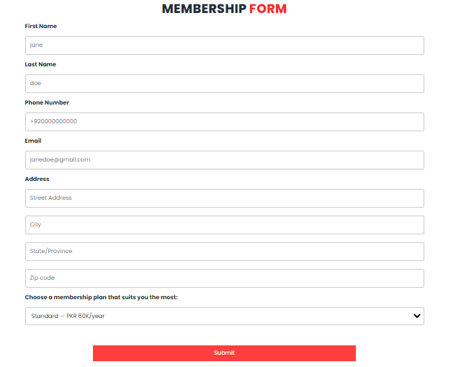MEMBERSHIP FORM page

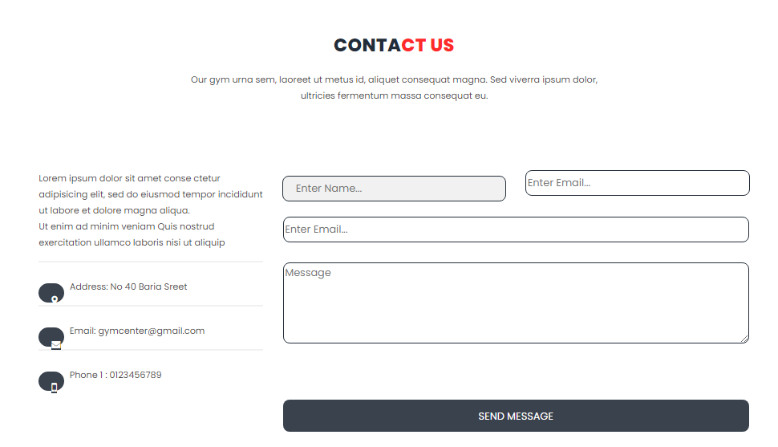contact us page

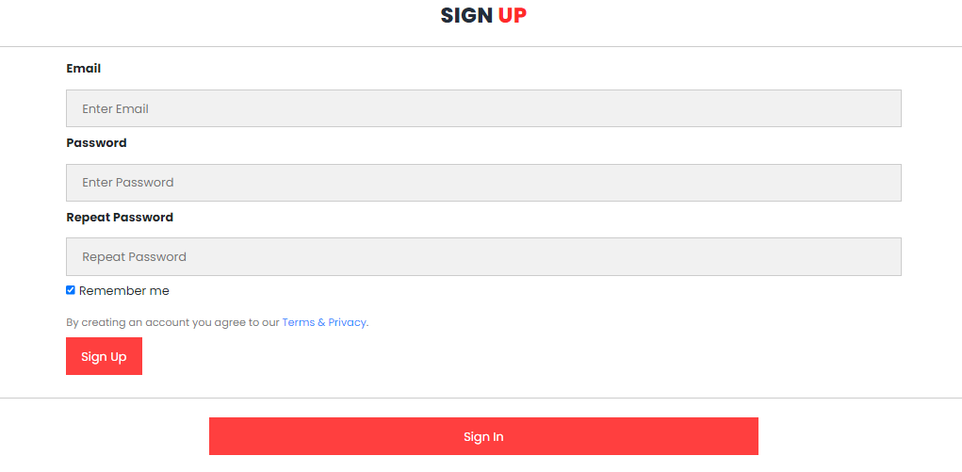Sign up page

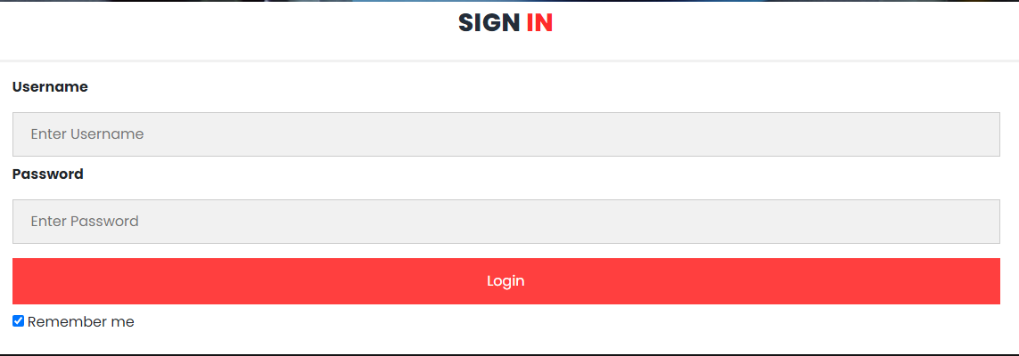

Sign in

More pic about website

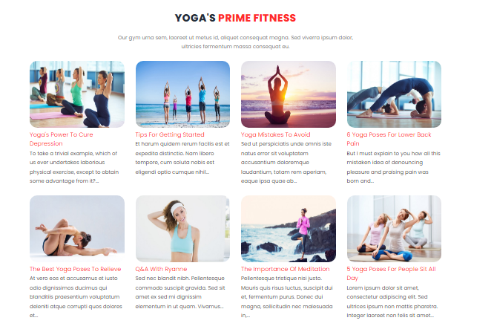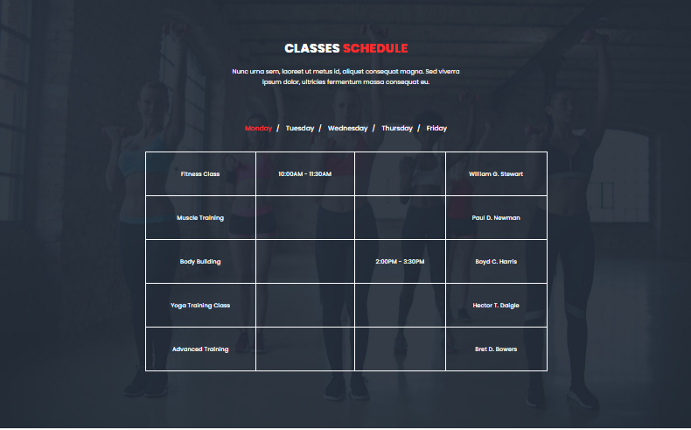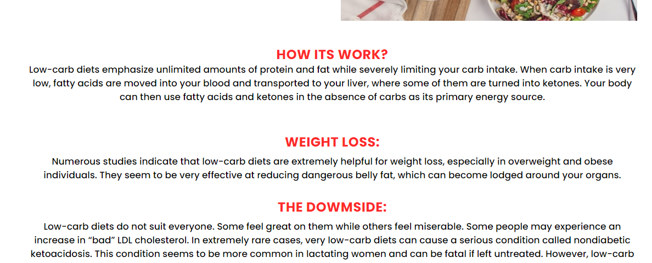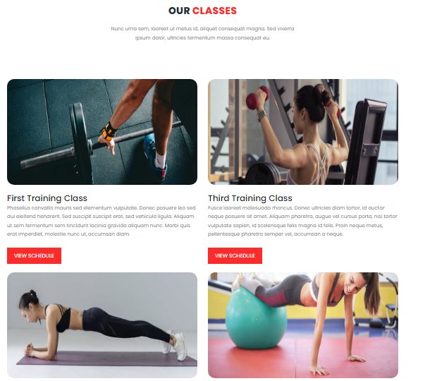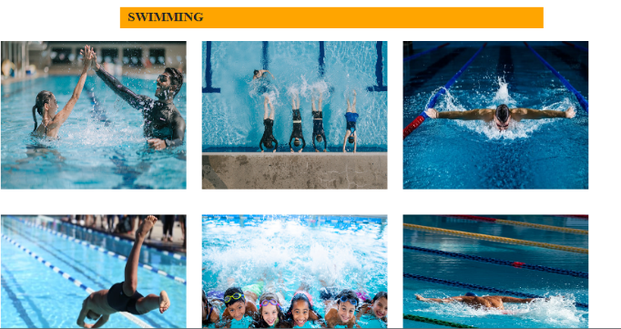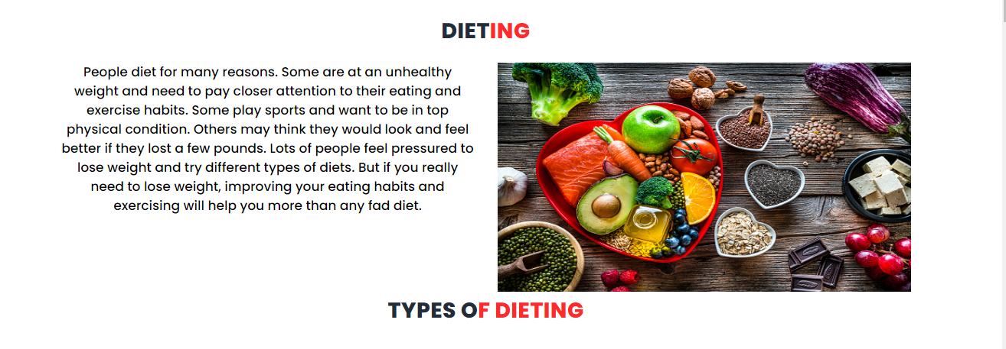

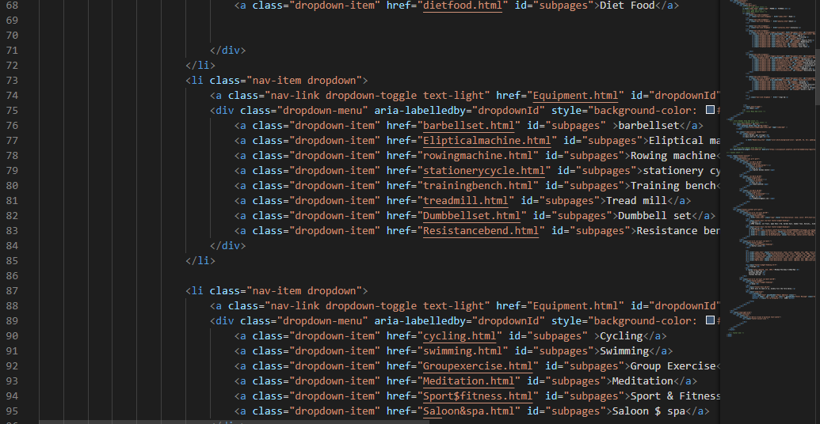Pic of code

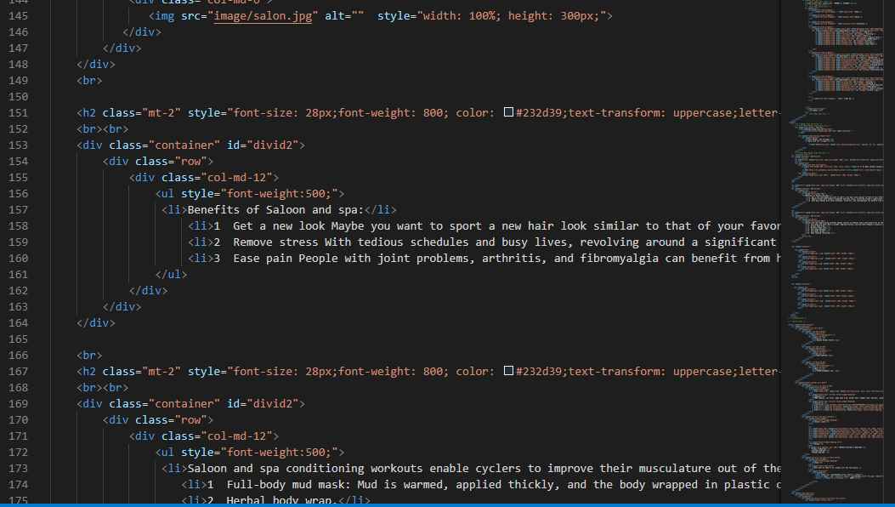

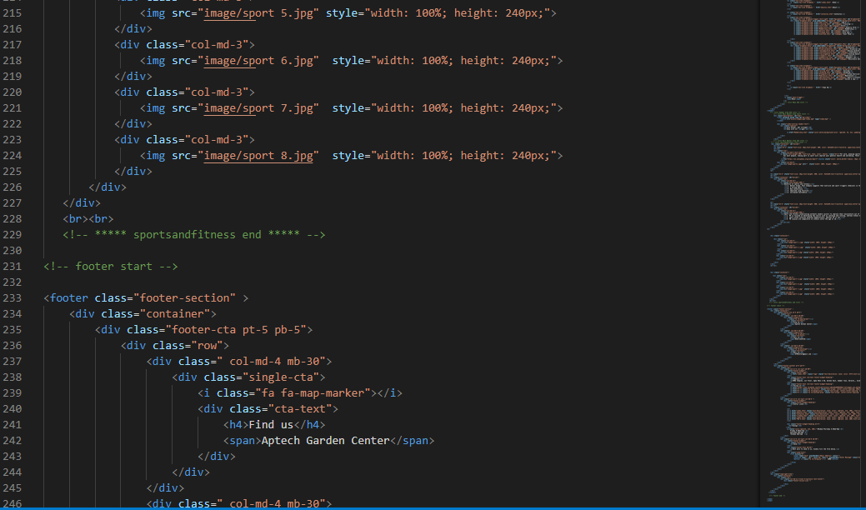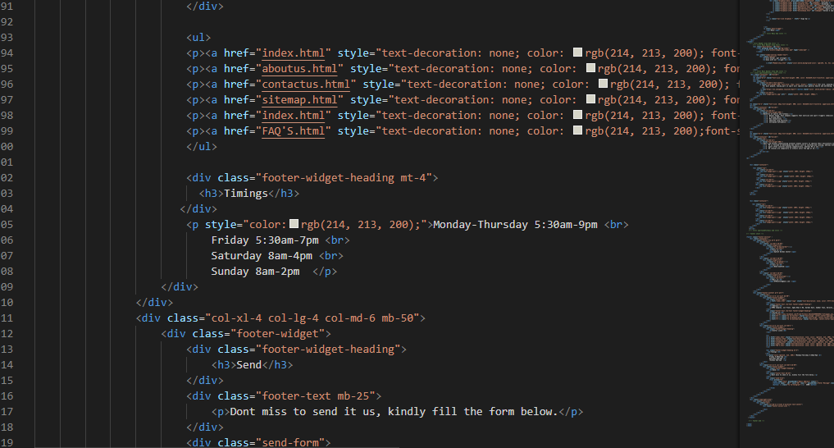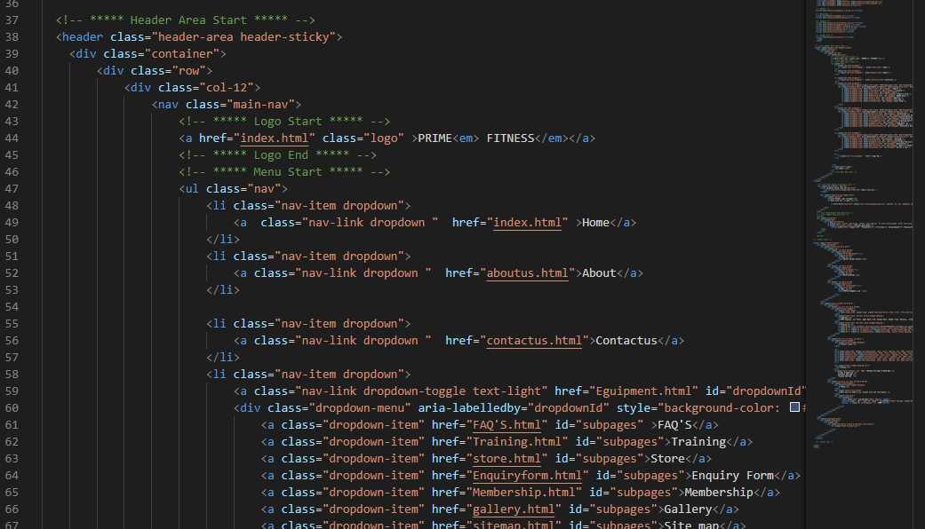

Task sheet

|  |  |  |  |  |  |  |
| --- | --- | --- | --- | --- | --- | --- |
| Project Ref. No:  Ep/Advertisement  Portal  Management system | | PROJECT  TITLE | Date Of preparation Of  Activity Plan | | | |
| No. | Task | P  R  I  M  E  -  F  I  T  N  E  S  S | Actual  Start Date | Actual  Days | Team-Mate  Name | Status |
| 01. | Website | 1  5  -  D  E  C  E  M  B  E  R  -  2  0  2  1 | 1  5  -  J  A  N  U  A  R  Y  -  2  0  2  2 | RIDA EMAN |  |
| 02. | DOCUMANTATION | SAIM JAWED |  |
| 03. | PRESENTATION | INSIYAN  YOUSUF |  |
|  |  | EBAD-UL-HASSAN |  |
|  |  |

***THANKS, YOU FOR***

***READING THE Documentation***

INTRO OF PRIME FITNESS

Prime Fitness is a fitness program provided at no cost

by your employer or health plan. It is a free fitness

program for participants aged 18-65 years old. NO

COST MEANS NO EXCUSES!! Prime Fitness includes

unlimited access to every participating gym and fitness

center in the network.

PRIME is owned and operated by Specialty Fitness

Systems (SFS), based in Northwestern PA. After

forming in early 2014, SFS acquired STRIVE Strength,

and their patented STRIVE adjustable cam technology.